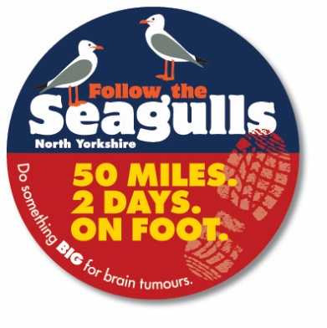
Itinerary – Follow the Seagulls North Yorkshire

Times are calculated based on a walking pace of 2.5mph/4kmph, which is a steady walking pace – adjust times for quicker or slower paces. Times have been adjusted by 30 mins after the lunch stop to allow time for a rest. Please read carefully the following notes and keep this itinerary with you at all times. All checkpoints will be manned by support staff who will be wearing high-vis vests, please ensure you check in at these points. Your key contacts are: Tom (07971 794273) & Eve (07906 582466)

Day One: Saturday

7:30am – START- Meet at the Whistlestop café, Whitby Station, Langborne Road, Whitby YO21 1YN for registration, collection of walker’s map and other useful items. Here you can also get an optional breakfast roll.
Please note: You will need to pay for your own refreshments here. No later than 8:00am – Depart Whitby.
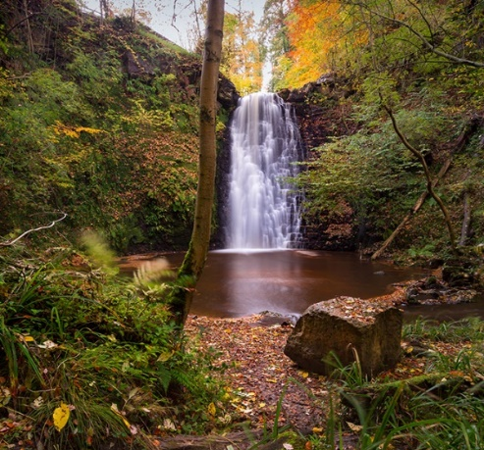
10:20am – CHECKPOINT 1 - Arrive at Falling Foss Tea Garden and waterfall (Mile 6). Here is a good opportunity to use the toilet facilities and have a short refreshment/lunch break. Pictured Right.
Please note: You will need to source your own lunch and refreshments if you haven’t already done so.

10:45am – Leave Falling Foss and continue with the walk along a small section of the coast to coast route before venturing on to Fylingdale Moor.

After walking past the large patch of forrest on your right down Robin Hood’s Bay Road (Path) you will arrive at a cross roads (highlighted on your map in pink right at the bottom of your map). Take care here because the paths are slightly different to how they appear on the map. Keep checking your surroundings and the map.

2:00pm – CHECKPOINT 2 - Arrive at the A171 crossing (Mile 13.25) and continue with walk towards Ravenscar.
Take extra care crossing the road here as it is a busy road and vehicles are travelling at speed.

2:45pm – Arrive near Ravenscar (Mile 15) and marvel at the majestic sea views of Robin Hood’s Bay.

3:15pm – Join the Cleveland Way (Mile 16.5).

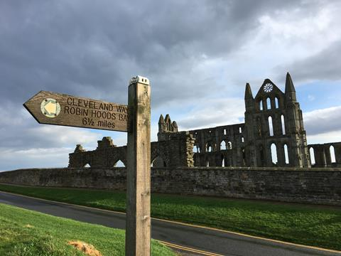
4:00pm – CHECKPOINT 3 - Arrive in Robin Hood’s Bay (Mile 18). Support staff will be outside the Victoria Hotel Sign. Here you can decide whether you want to catch the bus (the X93 service from Thorpe Lane on the side of the bus shelter) back to Whitby or, if you’re really feeling like a superhero, carry on with the final 6.5 Mile section of the trek along the undulating Cleveland Way.
Cut off time: For safety reasons, if you are not at this point by 4:30pm, you will be asked to make your own way back to Whitby on public transport or taxi as it will be too dangerous to use the coastal path.

6:30pm / 7:00pm – CHECKPOINT 4 - Arrive at Whitby Abbey for the finish of day one!

7:30pm – Meet for a meal together at Robertsons Fish & Chips Restaurant. (6-7 Bridge Street)

Main course and soft drink paid for by brainstrust for all walkers and helpers.

Itinerary – Follow the Seagulls North Yorkshire

Your key contacts are: Tom (07971 794273) & Eve (07906 582466)

Day Two: Sunday

07:30am – Meet our support staff in the car park at Whitby Railway Station (outside the Whistlestop café) for vehicle transfer to Danby Beacon.

08:00am START - Begin the trek from Danby Beacon (RAF Danby Beacon was an early warning radar station that formed part of the Chain Home network of radar stations built by the Royal Air Force immediately prior to the Second World War)

09:00am – CHECKPOINT 1 - Arrive at Scaling Dam (Mile 3). Take extra care walking along the road here.

10:15am – CHECKPOINT 2 – Before you arrive on to Borrowby Moor. Keep an eye out for our high vis jackets!

Arrive in outskirts of Staithes and cross the A174 (Mile 8) Take extra care crossing the road here

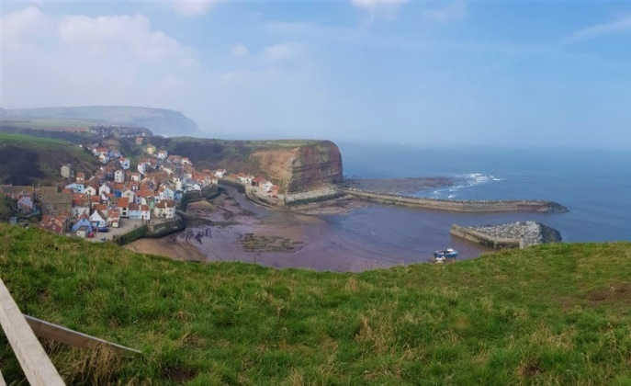
11:30am – CHECKPOINT 3 -. The Staithes Village Memorial Hall. (Turn right off Staithes Lane on to Cliff Road, the hall is next to the church) Whitby Endeavour Rotary Club are kindly donating hot drinks, soup, sandwiches and cake.

You can catch the Sapphire X4 bus at Staithes Lane End back to Whitby if you feel that you cannot walk any further.

12:30pm –Arrive in the pretty fishing harbour of Staithes (Mile 8.75)

1:35pm – CHECKPOINT 4 - Arrive at Runswick Bay (mile 11.5). Here you can catch the Sapphire X4 bus on Ellerby Lane (opposite The Runswick Bay Hotel) back to Whitby if you need to. Cut off time: For safety reasons, if you are not at this point by 2:35pm, you will be asked to make your own way back to Whitby on public transport or taxi.

3:30pm – CHECKPOINT 5 - Pass through Sandsend (Mile 18.5). The pier at Whitby Harbour is in sight! Support staff will be in the car park. Public toilets are also available.
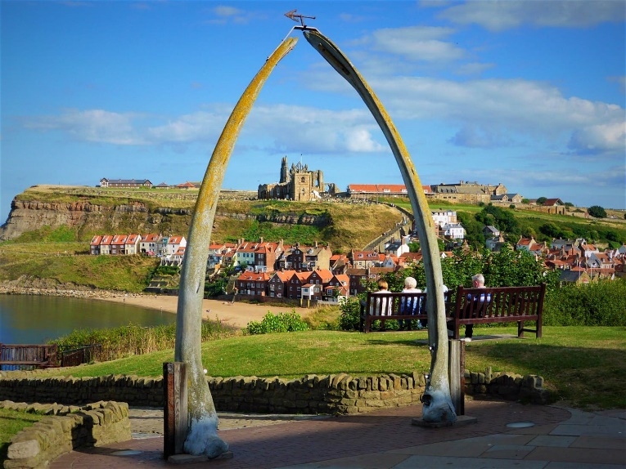
Here you can also catch the Sapphire X4 bus outside the Hart Inn back to Whitby.
Cut off time: For safety reasons, if you are not at this point by 4:15pm, you will be asked to make your own way back to Whitby on public transport or taxi.

Between 4:45pm and 5:15pm – CHECKPOINT 6 - Finish underneath the whalebone arch overlooking Whitby Harbour. Challenge completed!! Make your way across the road to the lounge bar in the Royal Hotel for an optional well-earned drink!

